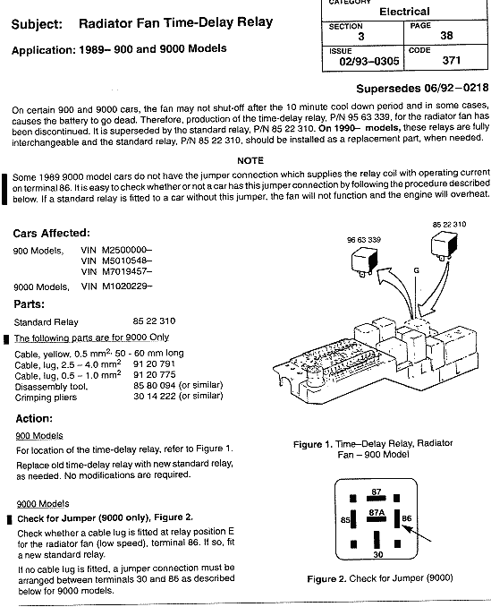
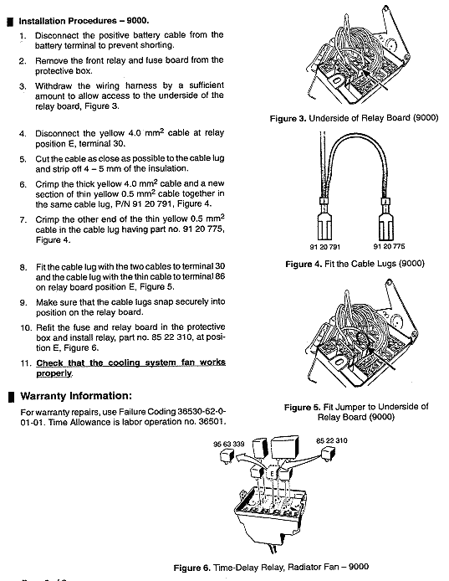
If you have problems with this bulletin's instructions, you can simply wire the 310 relay in so that +30 (power all the time) is on pin 30 of the relay, that the wire going to the fan is on pin 87 of the relay and pin 85 is either jumped from +30 ( fan will run with key off as long as the fan sensor is closed (hot engine)) or +15 ( power with the key on) ( fan will run with key on and fan sensor closed) and pin 86 connected to the blue wire from the fan sensor.

